**Summer 2023: ML 5710 (Assignment 2)** Mallika Mamidi (700746126)

**GitHub Link:** [**https://github.com/mallika76/MachineLearning-Assignment2.git**](https://github.com/mallika76/MachineLearning-Assignment2.git)

1. **Pandas**

Read the provided CSV file ‘data.csv’.

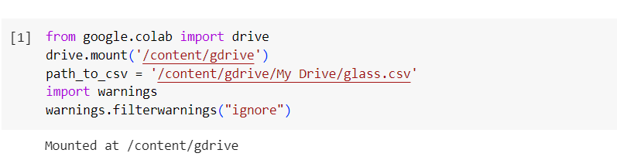

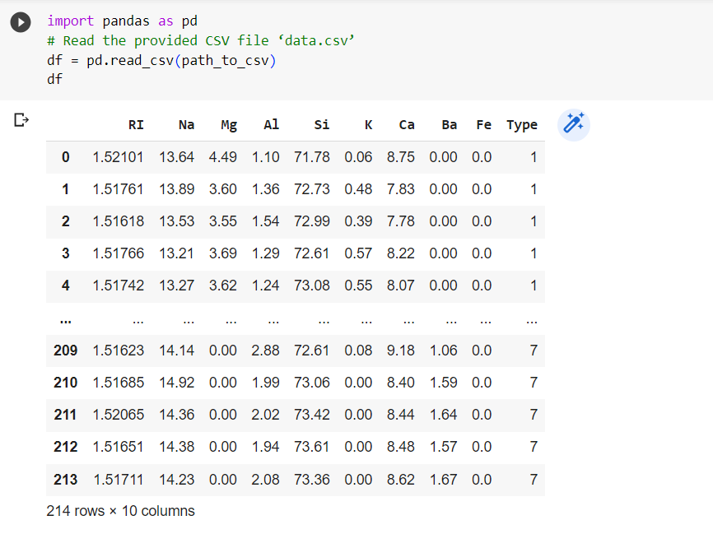

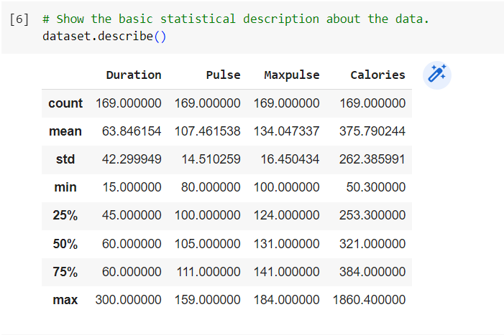

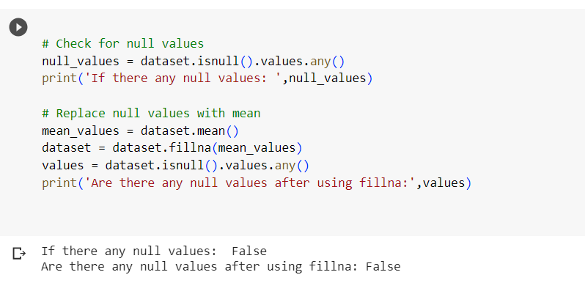

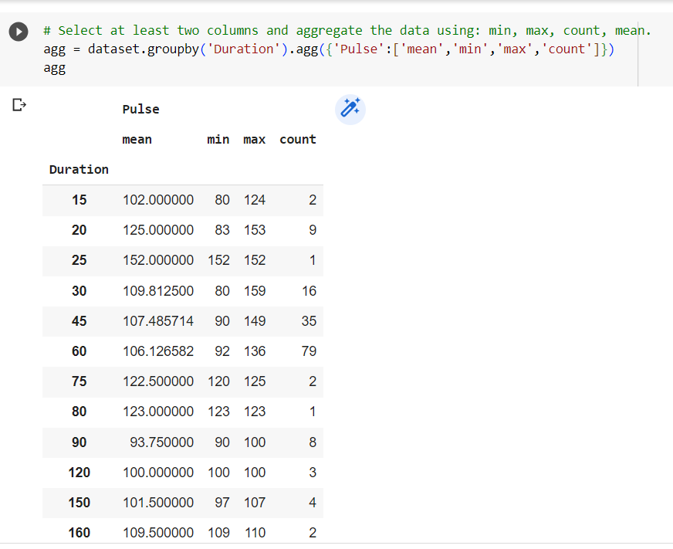

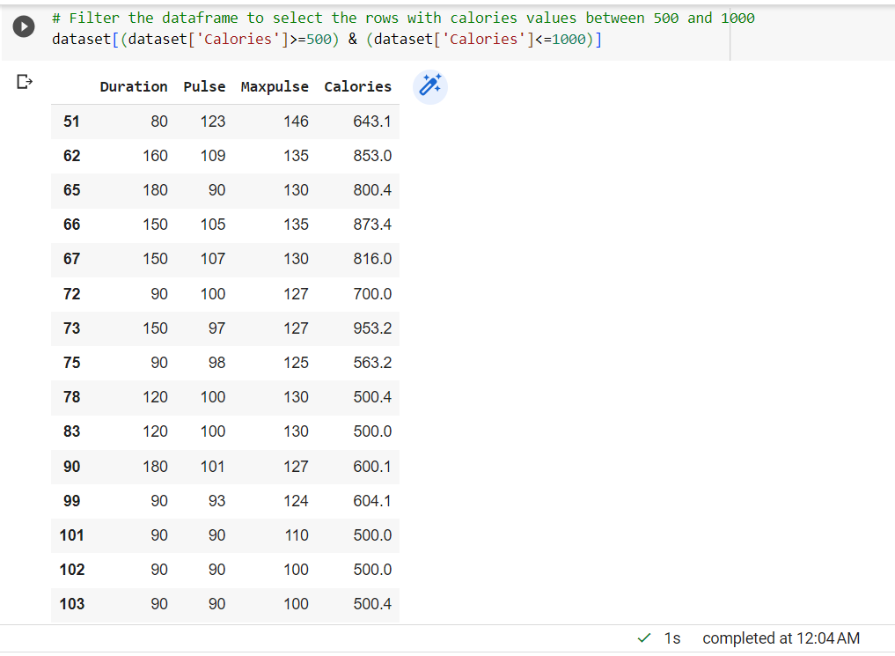

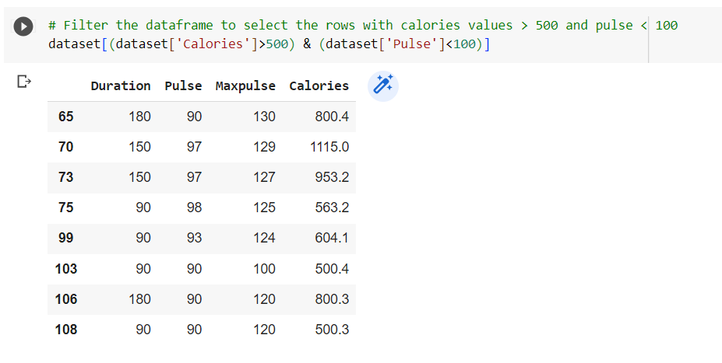

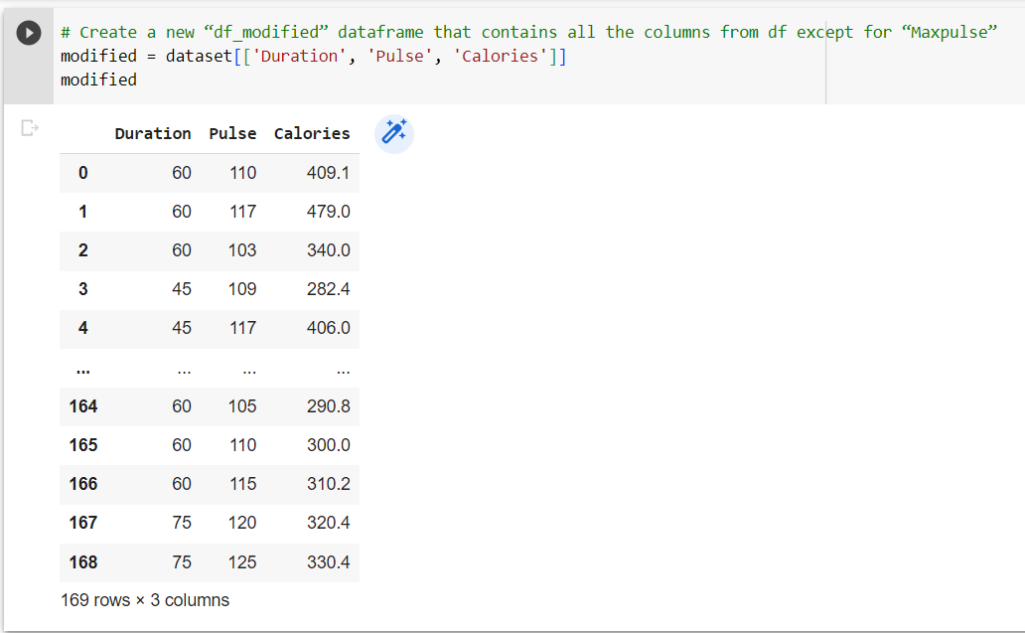

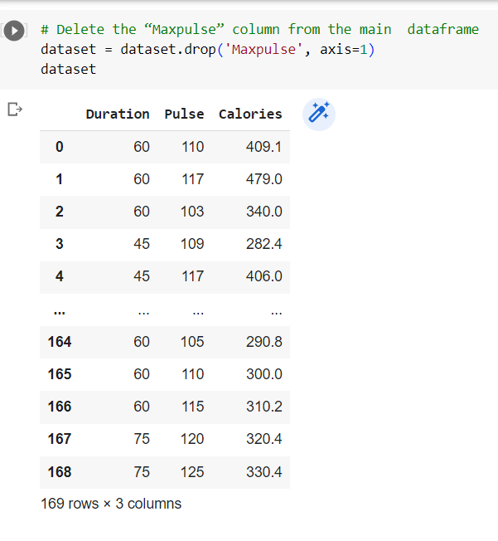

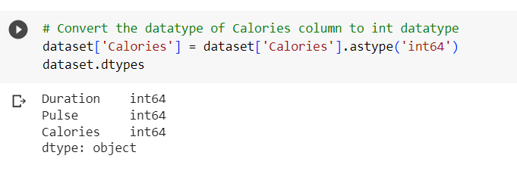

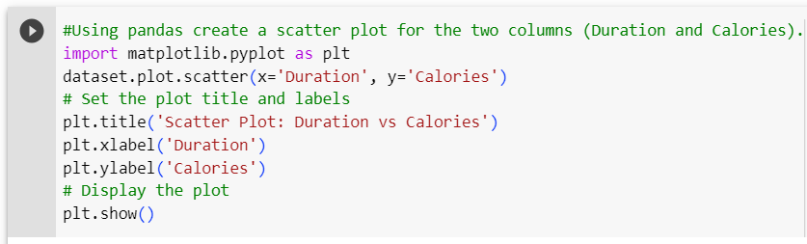

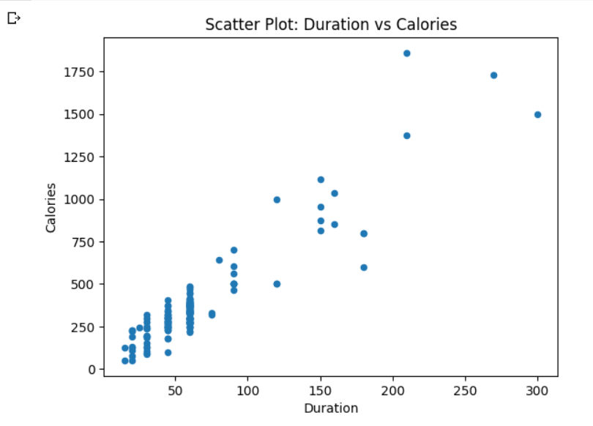

**2. Scikit-learn**

1. Implement Naïve Bayes method using scikit-learn library

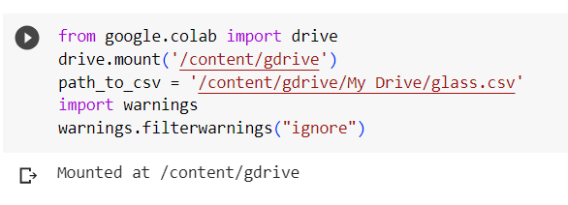

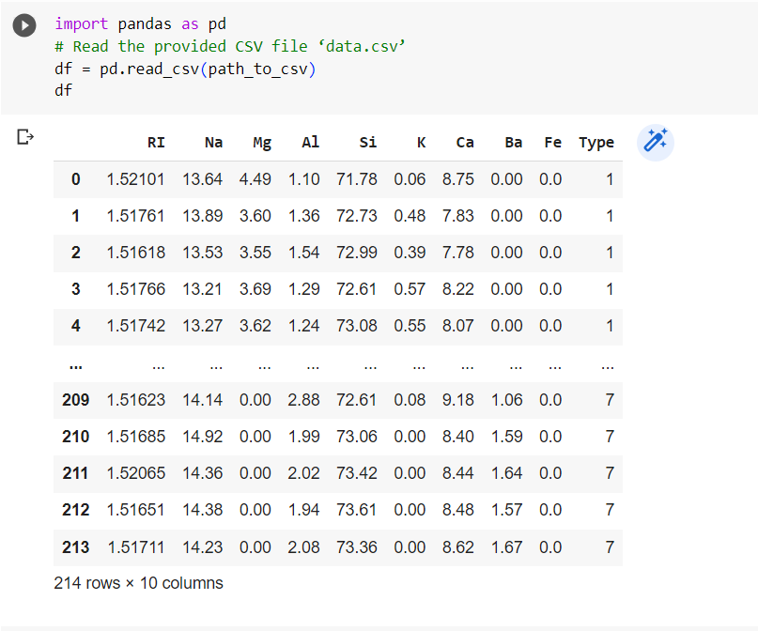

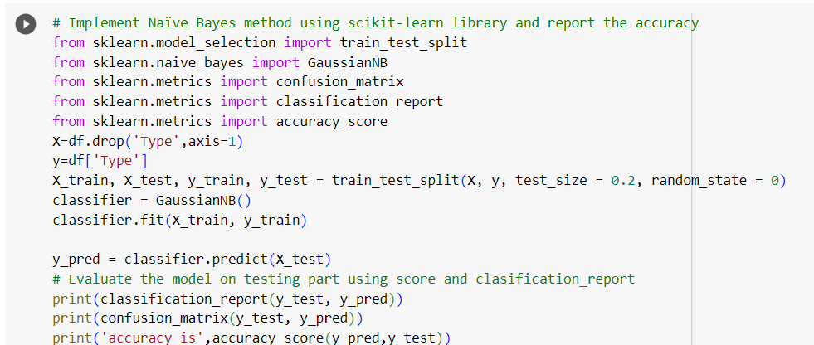

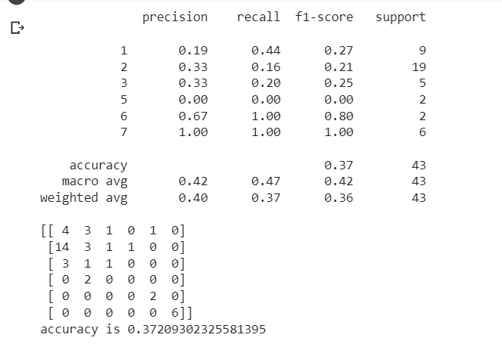

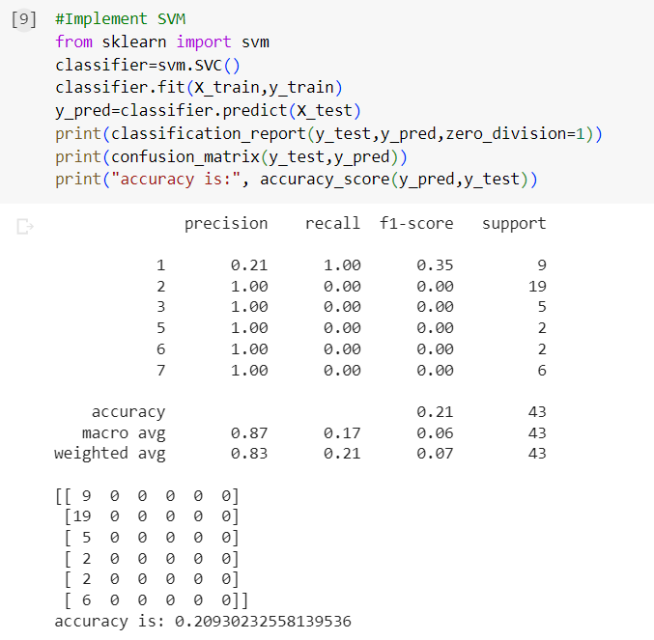

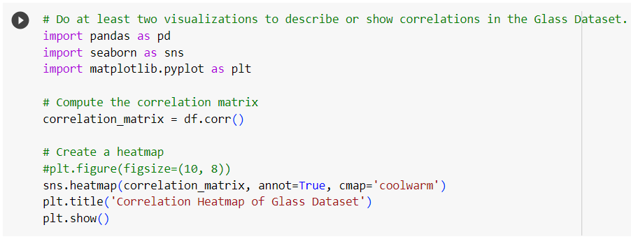

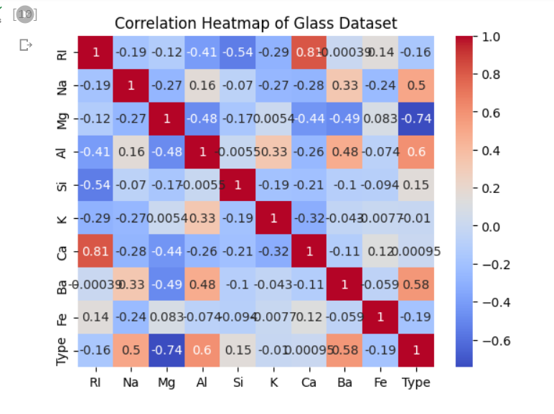

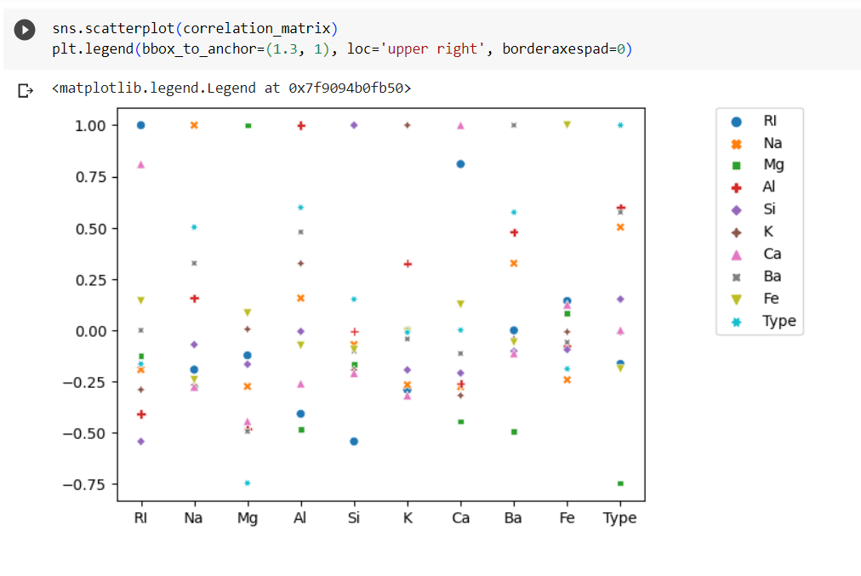

# **Which algorithm got better accuracy? Can you justify why?**

Naive Bayes outperformed SVM in accuracy, achieving higher accuracy of 0.3721 compared to 0.2093. Naive Bayes achieved better precision, recall, and F1-score, with a weighted average precision of 0.40, recall of 0.37, and F1-score of 0.36. SVM's precision was higher but may be misleading due to data imbalances. Naive Bayes missed a significant number of positive samples and performed poorly in terms of recall. Overall, Naive Bayes outperformed SVM in accuracy, precision, recall, and F1-score